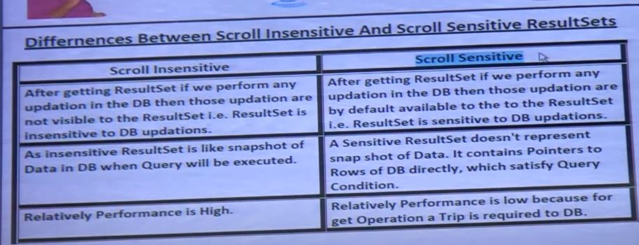

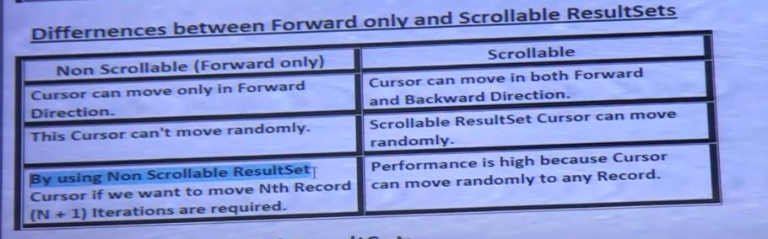

**ResultSet**

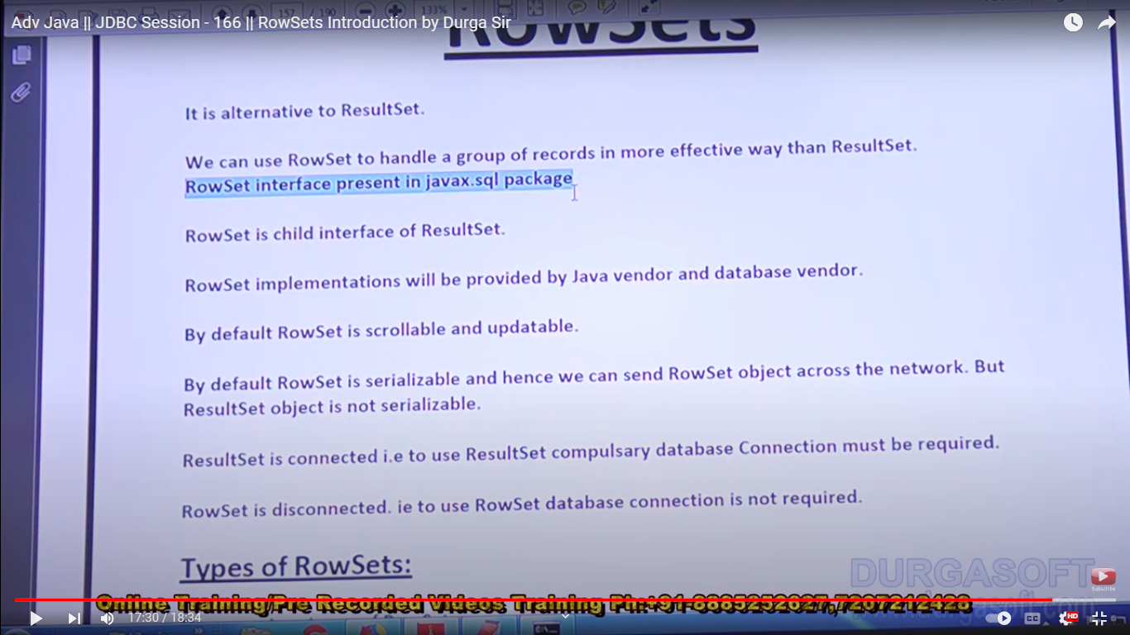

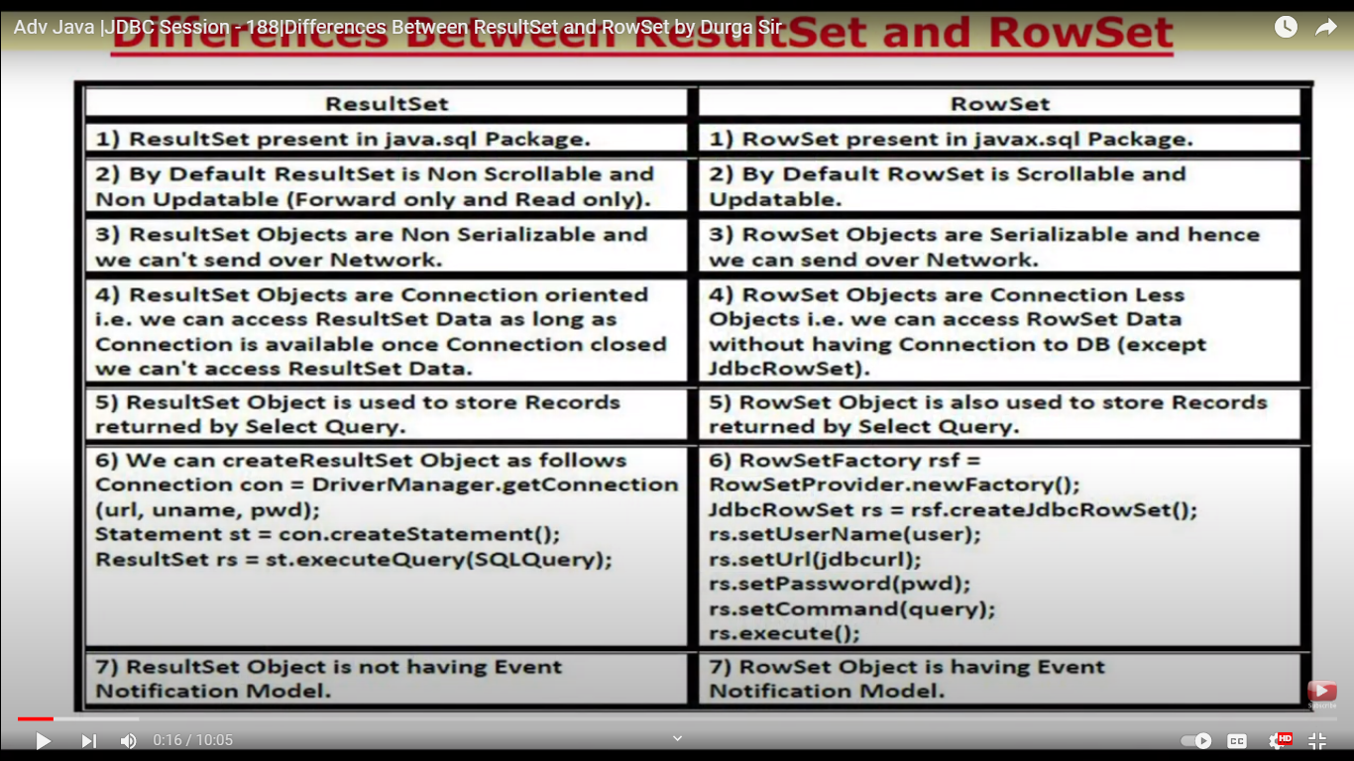

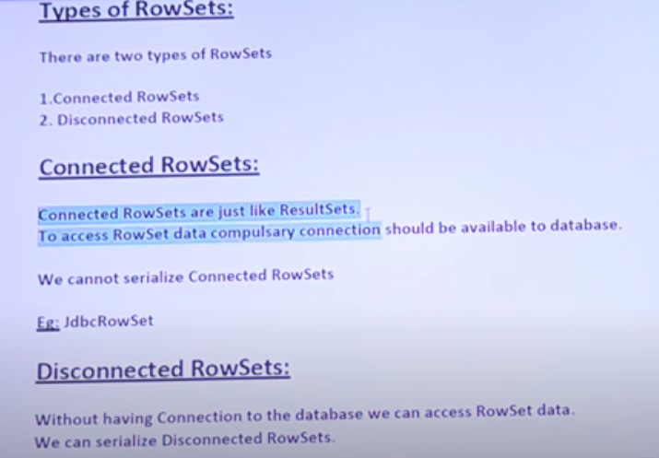

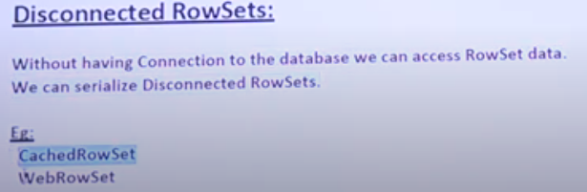

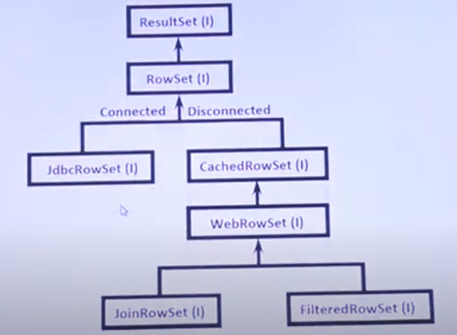

**JDBCRowset:**

* Child Interface of RowSet
* Exactly same as ResultSet ( connected and non-serializable)
* But
  + JDBCRowset is by default scrollable and updatable whereas ResultSet is by default forward –only and read only.

package dbexamples;

import javax.sql.rowset.*;

public class JDBCRowSetDemo {

public static void main(String[] args) throws Exception {

RowSetFactory rsf = RowSetProvider.newFactory();

JdbcRowSet rs = rsf.createJdbcRowSet();

rs.setUrl("jdbc:mysql://localhost:3306/demo_db");

rs.setUsername("root");

rs.setPassword("");

String myQuery = "SELECT*FROM employees";

rs.setCommand(myQuery);

rs.execute();

System.out.println("Employee Record in Forward Direction");

System.out.println("EMP ID \t NAME\t ADDRESS\t SALARY");

System.out.println("-------------------------------------------");

while(rs.next()){

int id = rs.getInt(1);

String name = rs.getString("name");

String address = rs.getString(3);

double salary = rs.getDouble("salary");

System.out.println(id+"\t"+name+"\t"+address+"\t"+salary);

System.out.println("-------------------------------------------");

}

System.out.println("Employee Record in BackWard Direction");

System.out.println("EMP ID \t NAME\t ADDRESS\t SALARY");

System.out.println("-------------------------------------------");

while(rs.previous()){

int id = rs.getInt(1);

String name = rs.getString("name");

String address = rs.getString(3);

double salary = rs.getDouble("salary");

System.out.println(id+"\t"+name+"\t"+address+"\t"+salary);

System.out.println("-------------------------------------------");

}

System.out.println("Employee Record Randomly");

rs.absolute(3);

System.out.println("EMP ID \t NAME\t ADDRESS\t SALARY");

int id = rs.getInt(1);

String name = rs.getString("name");

String address = rs.getString(3);

double salary = rs.getDouble("salary");

System.out.println(id+"\t"+name+"\t"+address+"\t"+salary);

rs.close();

}

}

